Ioterra, Inc.

<Product/Project Name>
PRODUCT REQUIREMENTS DEFINITION
<DATE>

Table of Contents
Product Description: <CLIENT AND PRODUCT NAME> 3
Stakeholders 3
COMMERCIAL AND REGULATORY 3
Regulatory Requirements 3
Labeling 4
Financials 4
Volume 4
ENVIRONMENT 4
Storage Environment 4
Operating Environment 4
INDUSTRIAL DESIGN 5
Mechanical 5
SOFTWARE AND DATA PROCESSING 6
ELECTRICAL HARDWARE 6
Block Diagram of Electrical Hardware 6
DURABILITY 7
PACKAGING 7
Serviceability 7
Revision History 8
Appendix A 9
Signatures 10

Product Description: <CLIENT AND PRODUCT NAME>

Market Need | Why does the world need this product? What is the problem that this device is going to solve?
Key Features/ Functionality | - Tell us here about the key features of the product and the functions it will perform.  - …
Other Product Compatibility | - If the device must work within a system of other devices, tell us about that here.  - ...
Stakeholders
End Users | Who are the end users for the device?
OEMS | Is the device going to be integrated into machinery, equipment, or products sold to others?
COMMERCIAL AND REGULATORY
Countries of Sale
Target Launch Date
Regulatory Requirements
Safety (UL, CE)
Emissions (FCC, CE)
Interoperability (Cellular, Wi-Fi)
Labeling
Regulatory Marks
Country of Origin
Serial Number
Financials
BOM Cost
COGs
MSRP
Acceptable Margin
Volume
MOQ of First Production Run
Annual Volume
Timeline for Product Refresh (EOL)
ENVIRONMENT
Storage Environment
Temperature Range
Operating Environment
Indoor, Outdoor, Wearable
Temperature Range
INDUSTRIAL DESIGN
Branding
Renderings | N/A – PCB shall be placed in COTS environmental enclosure. PCB should be about ~4” x 4” x 1-2” desired. Prototypes will be larger. Does not have to be square. You can insert a picture here…  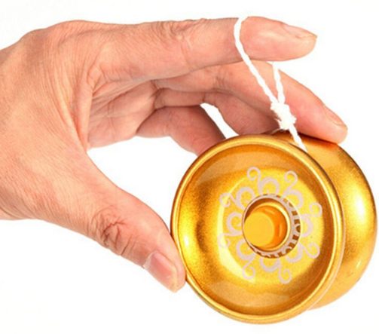  - For Example: This is a yo-yo.
Color, Material, and Finish (CMF)
Logo size and placement
Connectors
(Power, USB, Lighting, Audio)
Visual Interface
(Screen size and type, LEDs)
Touch Interface
(Mechanical actuators/switches, touch sensitivity, haptics)
Audio Interface
(Microphones, speakers, buzzers)
Mechanical
Dimensions
Weight
Mounting
Form Factor
(If important)
SOFTWARE AND DATA PROCESSING
Firmware Functions/Algorithms
Cloud Application
Smartphone Application
Transmitted Data and Rates
ELECTRICAL HARDWARE
Block Diagram of Electrical Hardware
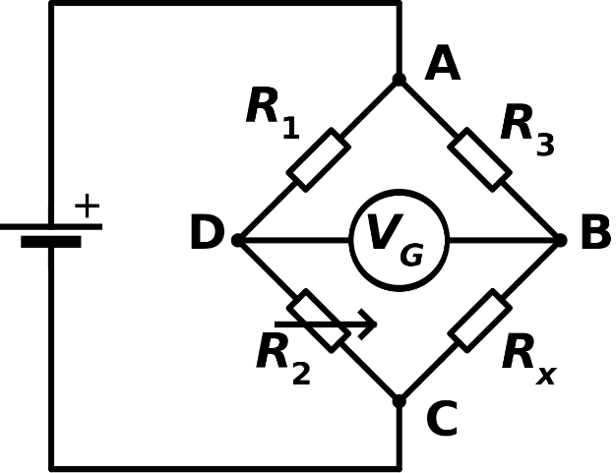
- For Example: This is a Wheatstone Bridge
Inputs /Sensor Requirements
Output/Actuator Requirements
Critical BOM Components
Communication Requirements
Power Requirements
DURABILITY
Lifetime requirements
Cycles of various sub-systems
Chemical resistance (sweat, sebum, sunscreen, salt water)
UV resistance (sunlight)
Environmental (Dust, Water, etc.)
Mechanical (Drop, Vibration, Abrasion, etc.)
PACKAGING
In the Box
Printing, colors, inserts, cardboard type, drop requirements
Retail Requirements
SKU Combinations
Serviceability
Repair Services
Returns Process
Repair/Return Qualifications/Tolerances
Customer Support System
Revision History
Version | Date | Author | Changes
1.0 |  |  | Initial Document Prepared

